Step 1: Right click on ‘Database’, click on create and select ‘Database’

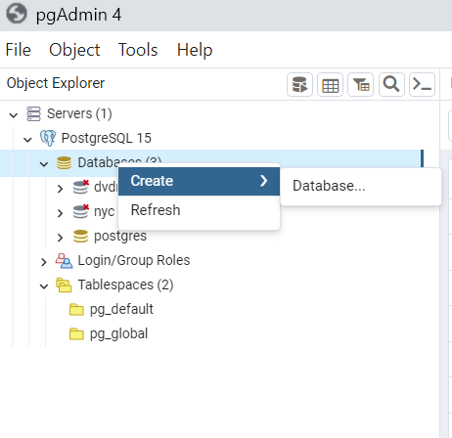

Step 2: Name the database GlycemicVariability (Copy and paste this if you want to be sure) and click on ‘Save’

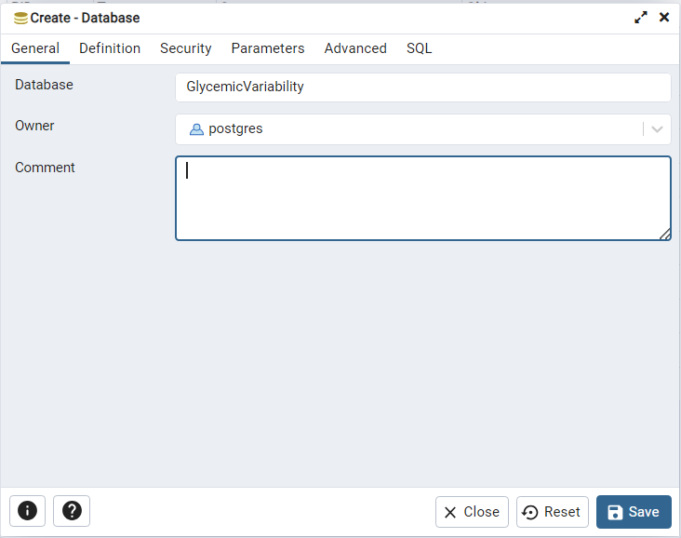

Step 3: Download the files GlycemicVariability from either GV Bak or GV Tar. The .bak file works well if you’re loading data to PGAdmin. If your PGAdmin is crashing or failing for some reason and you need a workaround, use the .tar file

Step 4: Right click on the database you just created : ‘GlycemicVariability’ and click on ‘Restore’

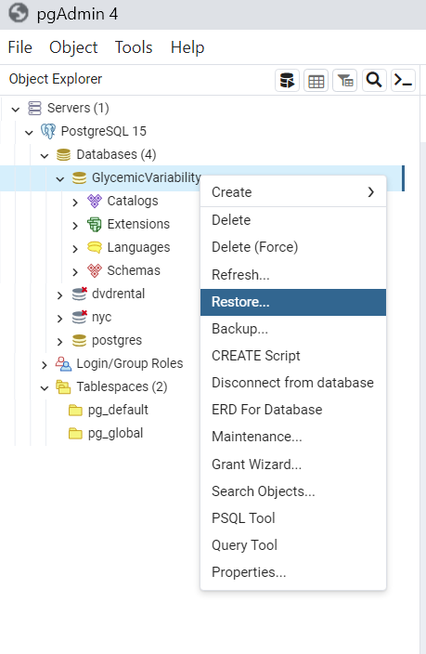

Step 5: Choose the format as ‘Custom or tar’ and then select the file you downloaded, from the folder location on your drive. Ensure that ‘All files’ is selected in the file browser window. Click restore.

